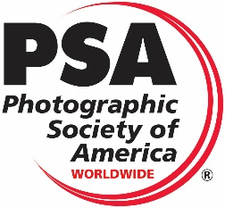
The 2023 Detroit International Stereo Exhibition
The
Detroit Stereographic Society

Exhibition Co-Chairs
Barbara Gauche | Dennis Green
46576 Vineyards Lane | 550 E. Webster
Macomb, MI 48042 | Ferndale, MI 48220
bpgauche@msn.com | dennisgreen@comcast.net
PSA 2023-501
PSA 3D Division

Panel of Judges for All 3 Sections  Al Huberty, Bloomfield Hills, Michigan, USA  Judge and International Stereo Exhibitor  David Smith, Dearborn, Michigan, USA  Judge and International Stereo Exhibitor  Rusty Soderberg, Mason, Michigan, USA  Judge and International Stereo Exhibitor |  | Calendar  Closing Date Monday, October 23, 2023  All Judging Completed By Saturday, October 28, 2023  Results and Digital Exhibition  Posted on the Internet By Saturday, November 11, 2023  Report Cards E-Mailed By Saturday, November 11, 2023  Awards Mailed By Saturday, December 23, 2023  Catalogs posted on the website By Saturday, December 23, 2023  Exhibition Dates  Cleveland, Ohio Tuesday, January 2, 2024  Livonia, Michigan Wednesday, January 10, 2024  Sections Included in this Exhibition  Stereo Digital Section – “Open”  Stereo Digital Section – “Creative”  Stereo Digital Section – “Animals/People”
Entry forms may be obtained through the Exhibition Page on the DSS Website: www.Detroit3D.org
 | Awards
Stereo Digital Section –  “Open” | Stereo Digital Section –  “Creative” |  | Stereo Digital Section –  “Animals/People”
Best of Show (PSA 3D Division Gold Medal) | Best of Show (PSA 3D Division Gold Medal) |  | Best of Show (PSA 3D Division Gold Medal)
Best “Fishing” (Helin Tackle Award) | Best “Slow Shutter” |  | Best “Humor”
3 Judge’s Choice Awards  1 Chairman’s Choice Awards  Honorable Mention (10% of the balance of accepted Section images) | 3 Judge’s Choice Awards  1 Chairman’s Choice Awards  Honorable Mention (10% of the balance of accepted Section images) |  | 3 Judge’s Choice Awards  1 Chairman’s Choice Awards  Honorable Mention (10% of the balance of accepted Section images)

All Award Winners, HMs and Acceptances will be posted on the Internet at the following Web Site: www.Detroit3D.org click on “Exhibitions”

IMAGE AND ENTRY REQUIREMENTS
This exhibition is open to anyone; however, an entry may be rejected when the Sponsor or the Exhibition Organizers, in their reasonable discretion, believes the entry does not conform to exhibition rules and these Conditions of Entry. Membership in any photographic organization is not required.

PENALTIES
Entries will not be accepted from any entrant who has put on the PSA Penalties List for Ethics Violation. Entry fees are not refundable in these circumstances.

PSA STAR RATINGS
To receive proper Star ratings credit from PSA, entrants must provide their names and country exactly the same way in each exhibition. Aliases are not permitted. Please contact PSA in the event of name changes or relocating to another country. Using one’s name differently in different exhibition exposes the entrant to the risk that many of their acceptances may not be recognized by PSA Star Ratings.

IMAGE CREATION
Entries must originate as photographs (image-captures of objects via light sensitivity) made by the entrant on photographic emulsion or acquired digitally.

CERTIFICATION
By virtue of submitting an image, the entrant certifies the work as his or her own. Images may not incorporate elements produced by anyone else (for example: clip art, images or art by others downloaded from the Internet). Aliases are not allowed.

REPRODUCTION
The entrant permits the sponsors to reproduce all or part of the entered material free of charge for publication and/or display in media related to the exhibition. This may include low resolution posting on a website. The Photographic Society of America (PSA) may request specific permission from entrants to reproduce entered images in its educational materials. The terms of that permission will be mutually agreed between the entrant and PSA except in the circumstances where the entered image is found to breach the PSA Ethics Policy. In those circumstances the image may be reproduced by PSA, without the entrant’s further permission, for educational purposes to illustrate serious exhibition rule violations. For those reproductions, the entrant’s name will be withheld.
Entries will not be accepted from entrants who indicate that their images may not be reproduced in materials related to the exhibition.” The exhibition assumes no liability of any misuse of copyright.

ALTERATION AND COMPUTER GENERATION
Subject to Divisional restrictions (particularly Nature, Photo Travel, and Photojournalism) images may be altered, either electronically or otherwise, by the entrant; adjustments to enhance images or creatively modify images are allowed providing the underlying photograph is retained in a way that is obvious to the viewer. Images may not be constructed entirely with a computer and must be the sole work of the entrant.

RE-USE OF ACCEPTED IMAGES
Any image that has been accepted in this exhibition, past or present*, may not be entered again in the same Division Star Ratings Class in any future instances of this exhibition. It may, of course, be entered in any other PSA recognised exhibitions but must always have the same title. Re-titling in another language is not allowed.

ENTRY
An Entry consists of, up to and including, four (4) images entered by a single entrant into the same Section. An entrant may only enter a specific Section once. Entrants may not enter identical or similar images into the same section or different sections of the same exhibition.

TITLES
Each image must have a unique title that is a description of the image. That unique title must be used for entry of that image or of an identical Image into any and all PSA-Recognized exhibitions. Titles must be 35 characters or fewer. No titles may be visible to the judges, and nothing in the image may identify the entrant. Titles may not include file extensions such as .jpg or .jpeg (or any other camera capture filenames such as IMG 471). Titles may not consist of personal identifiers possibly augmented by a number; or include words such as “untitled” or “no title”. Titles may not consist solely of numbers unless those numbers are prominently contained within the image, such as a contestant number in a race.

COLOR AND MONOCHROME
Color and Monochrome images from the same capture that share substantial pictorial content in common will be considered the same image and must be given the same title.

THE EXHIBITION WILL BE CONDUCTED IN ACCORDANCE WITH THE RULES OF THE PSA
An entrant’s images will not be presented to the judges consecutively. An entrant’s four images will be distributed throughout four rounds of judging in that section. Distribution of images will be in the same round order as submitted by the entrant. At no stage will a judge be able to view all the entrant’s images together.

DATA PROTECTION
By entering this exhibition, you are explicitly consenting to the personal details you have supplied, including physical addresses, email addresses, being held, processed and used by the exhibition organizers for purposes associated with this exhibition. You also explicitly consent to such information being sent to organizations that have accorded official recognition, patronage or accreditation to this exhibition. You acknowledge, agree and accept that by entering this exhibition, your participation status which includes your first and last name, name of the country used during registration at the exhibition, number of sections entered and number of photos entered in those sections will be made public in a published status list and that the results of your entry shall be made public in exhibition gallery, exhibition catalog. You also agree and accept the policy regarding Breaches of Rules of the PSA.

SUBJECT MATTER AND SECTION DEFINITIONS
The fundamental rule that must be observed at all times and applies to all sections offered in exhibitions with PSA recognition is that the welfare of living creatures is more important than any photograph. This means that practices such as baiting of subjects with a living creature and removal of birds from nests, for the purpose of obtaining a photograph, are highly unethical, and such photographs are not allowed in any exhibition with PSA recognition. Under no circumstances may a living creature be placed in a situation where it will be killed, injured or stressed for the purpose of obtaining a photograph. Images that show live creatures being fed to captive animals, birds or reptiles are not permitted under any circumstances.
There are also concerns about the use of aerial photography, drones, helicopters, low flying aircraft. These should not cause any interference with other individuals or animals which causes a disturbance in their normal activity or disrupt the way any individuals or animals interact with their environment. Entrants in PSA recognized exhibitions should comply with all relevant laws and regulations, associated with aerial photography, in the country in which the image was taken.

Entry into PSA recognized exhibitions is conditional on accepting these policies. The content of images must comply with the General Conditions and with the Division and Section definitions listed in these conditions. Images that - in the sole opinion of the judges or the Exhibition Organizers - do not comply, will be disqualified so the entrant may be aware of the problem when considering entry into other exhibitions with PSA recognition.

PSA MONOCHROME DEFINITION
An image is considered to be Monochrome only if it gives the impression of having no color (i.e., contains only shades of grey which can include pure black and pure white) OR it gives the impression of being a greyscale image that has been toned in one color across the entire image. (For example, by Sepia, red, gold, etc.) A greyscale or multi-colored image modified or giving the impression of having been modified by partial toning, multi-toning or by the inclusion of spot coloring does not meet the definition of monochrome and shall be classified as a Color Work.

BREACHES OF RULES
Entrants are strongly advised to look at the PSA Ethics Policy which can be found at https://psa-photo.org/page/ethical-practices.
If, at any time, it is determined in the reasonable discretion of the exhibition organizer or the judges before, during, or after the judging of an exhibition that an entrant has submitted entries where one or more images may fail to comply with these Conditions of Entry, including the stated definitions, exhibitions, on behalf of the judges, are allowed to request unedited or raw files of the submitted image.
In order to ensure that images comply with the Conditions of Entry and definitions, the exhibition organizers may carry out reasonable measures to verify that:
a) the images are the original work of the entrant and
b) the images comply with the rules and definitions as set out in these Conditions of Entry
These steps include, but are not limited to, questioning any entrant, requiring the submission of RAW files or other digital files representing the original capture of the submitted image(s), confronting the entrant with evidence that one or more submitted images fails to comply with the Conditions of Entry (also known as Entry Rules), and offering the entrant a reasonable opportunity to provide counter evidence to refute the exhibition organizer’s evidence by a set deadline. Such entries that are not cleared or are still questionable after the entrant has presented evidence may be considered in breach of these Conditions of Entry, and declined. Such entries may be referred to PSA for further investigation of possible ethics violations.
PSA, on receiving reports from exhibitions of possible breaches, retains the right to investigate in any way all complaints/suspicions of breaches of entry conditions, impose penalties if deemed necessary, void the acceptances of any image found to violate the PSA rules, include the entrant’s name on the list of sanctions provided to Exhibitions, and share such investigations with FIAP. Entrants automatically agree to these terms by the act of entering the Exhibition and agree to cooperate with any investigation.
If another party is submitting images on the entrant’s behalf, the entrant will still be held responsible for adhering to these Conditions of Entry (Entry Rules) and will be subject to penalties for any violations to these Conditions of Entry and PSA’s Statement of Ethics that may result.
If another party is processing images for an entrant or submitting images on the entrant’s behalf, the entrant will still be held responsible for adhering to all Conditions of Entry including the specific conditions in the relevant definitions.

NOTICE
When entrants fill in the Entry Form to submit an entry they will see the following feature to affirm they have read these Conditions of Entry:
“I hereby confirm that I have read, understood and agree to the Conditions of Entry of this exhibition. I have read the PSA document to be found at https://psa-photo.org/resource/resmgr/pdf/exhibitions_/exhibition-entrants-agreemen.pdf . I am aware that PSA may apply penalties for breaches of these Conditions of Entry.”
Failure to agree will mean that the application will not proceed.

NUMBER OF ENTRIES
A maximum of four entries may be submitted for each section. Images (Slides or Digital) previously accepted at a Detroit International Stereo Exhibition*, or so similar as to be almost identical, regardless of title, are ineligible in any format. New work is required. An entrant's four images in a section will be distributed throughout four rounds of judging.

CATEGORIES
Attention is drawn to the awards allocated to various categories, and entries are especially sought for all of these.

ACCEPTANCES
A maximum of 45% of entries will be accepted in each section.

ENTRY FEE
The entry fee is USD$6.00 per section worldwide. Cash or USD$ check made payable to “DSS” may be sent for one or all sections. Checks should be sent to:
Dennis Green
550 E Webster Street
Ferndale, MI 48220
PayPal payments sent to DennisGreen@Comcast.net may be made for one or all sections.

CATALOG
A PDF downloadable copy of the catalog will be put on the website and the list of acceptances, awards, etc. will be sent to PSA 3D Directors compiling “Who’s Who in Stereo Photography,” “Star Ratings” and “Image of the Year” records.

E-MAILED REPORT CARDS
Report cards will be sent to the “Preferred E-Mail Address for Correspondence” specified in the entry form.

MODIFICATION
Any modification of original images must be made by, or under the direction of, the exhibitor.
- Also applies to any images accepted in the Exhibition under its previous titles, the Detroit International Stereo Slide Exhibition and the Detroit International Salon of Photography.

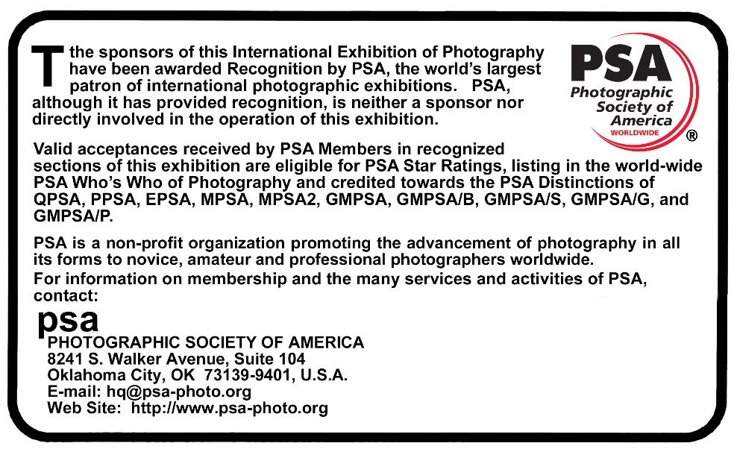
Stereo Digital Image Instructions
Each stereo image entry must consist of a single parallel view JPEG file. Maximum file size of each file should not exceed 2MB, total not to exceed 8MB. Maximum image width (horizontal) of each individual image is 1920 pixels and the height (vertical) is 1080 pixels, resulting in a combined file dimension of 3840 by 1080 pixels. We recommend the resize or multi-conversion features of StereoPhoto Maker for resizing from the original image dimensions to the required size.
File Naming: Please name the files containing your images as follows:
Lastname_Firstname_Image Title_n.jpg
Where n=1, 2, 3, and 4 in the order you wish them to be judged.
(Example: Gauche_Paul_Sunset at the Lake_1.jpg)
Please use underscores to separate the segments, and spaces (or hyphens where appropriate) between words in the image title, but no other special characters such as commas, brackets, periods, slashes, etc. If you have any questions regarding this format, please contact the Exhibition Chairman.

Judging Method
Judging will be by projection using a single full HD Optoma HD26 3D projector or by using a single LG UH8500 (UHD 3D TV) in a single session with all judges for each section present, if possible, based on state laws regarding the number of people allowed to meet in a group. If the judges are not able to meet in a group, they will judge the images on their own personal viewing equipment.
- (a) For onsite judging: the equipment to be used in the judging, computer and projectors, has been color calibrated.
(b) For remote judging: judges will be required to use color-calibrated monitors.
(c) In either case that projection equipment or computer monitors are required to be capable of displaying images at 100% of the image resolution and that images will be displayed at exactly 100% of their resolution (that is, that the images will not be enlarged beyond their native resolution).

Submission
Entries for each section must be sent in separate E-mails.

Attach all four entries to an E-mail and send to: DennisGreen@Comcast.net

Please include “Detroit Exhibition Entries – Section Title” in the subject line. We will try to acknowledge receipt of the E-mail within 48 hours. If you have not received acknowledgement within 48 hours, please contact us again so we can ensure your images are included in the judging. If you have a problem with E-mail reaching the above address, use the following alternate E-mail address: bpgauche@msn.com.

Copy the following and include the completed information in your E-mail:

“I have read the General Information and Conditions of Entry for this Exhibition.”
Name________________________________________________________________
Address______________________________________________________________
City ______________________________ State/Province______________________
Zip/Postal Code___________ Country_____________________________________
Preferred E-Mail Address for Correspondence________________________________
PSA Star Rating_____________________ PSA Honors_______________________

